A Project Report On

“Find & Explore”

Submitted To

Savitribai Phule Pune University

In partial fulfilment of the degree of

Bachelor of Business Administration – Computer Application

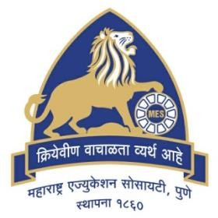

By

**Karan Nawal**

**&**

**Sohana Joglekar**

Roll No:

(**14412 & 14415)**

BBA-CA SemesterIV

Under the guidance of

**Mrs. Padma Nene** Research Guide

MES Garware College of Commerce, Karve Road, Pune 411004 (2

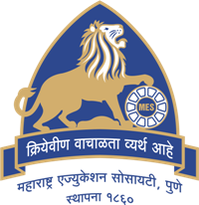

**Maharashtra Education Society’s**

**GARWARE COLLEGE OF COMMERCE**

**Karve Road, Deccan Gymkhana,** **Pune41104**

**CERTIFICATE**

This is to certify that **Sohana Joglekar**, Roll number **14415** has successfully completed the Project entitled “Find & Explore” and has submitted the same to the satisfaction during the academic year 2021 – 2022 towards partial fulfilment of the degree ‘Bachelor of Business Administration -Computer Application’ of Savitribai Phule University of Pune.

(PROJECT GUIDE) (BBA-CA IN CHARGE) (PRINCIPAL)

(INTERNAL EXAMINER) (EXTERNAL EXAMINER)

**ACKNOWLEDGEMENT**

We express our sincere regard and indebtedness to our project guide **Mrs. Padma Nene**, for her valuable time, guidance, encouragement, support, and co-operation throughout the duration of our project. This project gave us the opportunity to work on enhancing our technical skills while creating helpful website for tourists during this project.

This project helped in understanding the various parameters which are involved in the development of a static web application and the working and integration of front end to create a fully functional web application.

We would like to thank all the faculty members of department for their constant support and encouragement.

**INDEX**

1. **Introduction**
2. **Objectives**
3. **System Design**
4. **Form Design**
5. **Software/Hardware specifications**
6. **Future Scope**
7. **Conclusion**
8. **References**

**INTRODUCTION TO SYSTEM**

The purpose of this study was to develop Tourism Information System. It’s used to know about tours from anywhere in the world by a single dynamic website which will help the user to know everything about the places and tour details in a single website. It is a user-friendly platform for all travelers which can be easily used to know all details. Nearly everyone goes on a vacation and for them ‘Find & Explore’ would play a vital role in planning the perfect trip. The Tourism Information System allows the user to access all the details such as location, accommodation, activities etc.

The Tourism Information System thus offers functionalities to quickly access Places, Hotels, Restaurants and Commute. It provides up to date information, revised hotel rates and transport schedules. This will therefore establish ease of approach between tourists and their desired vacation.

**Objectives:**

This website will strive to:

1. To ensure tourists find their desired information.
2. To manage the information about various travel destinations within Maharashtra State.
3. To check the current rates of hotels.
4. One stop destination for all your travel enquiries.
5. Support fast searching.

**System Design:**

* Entity Relationship Diagram:-

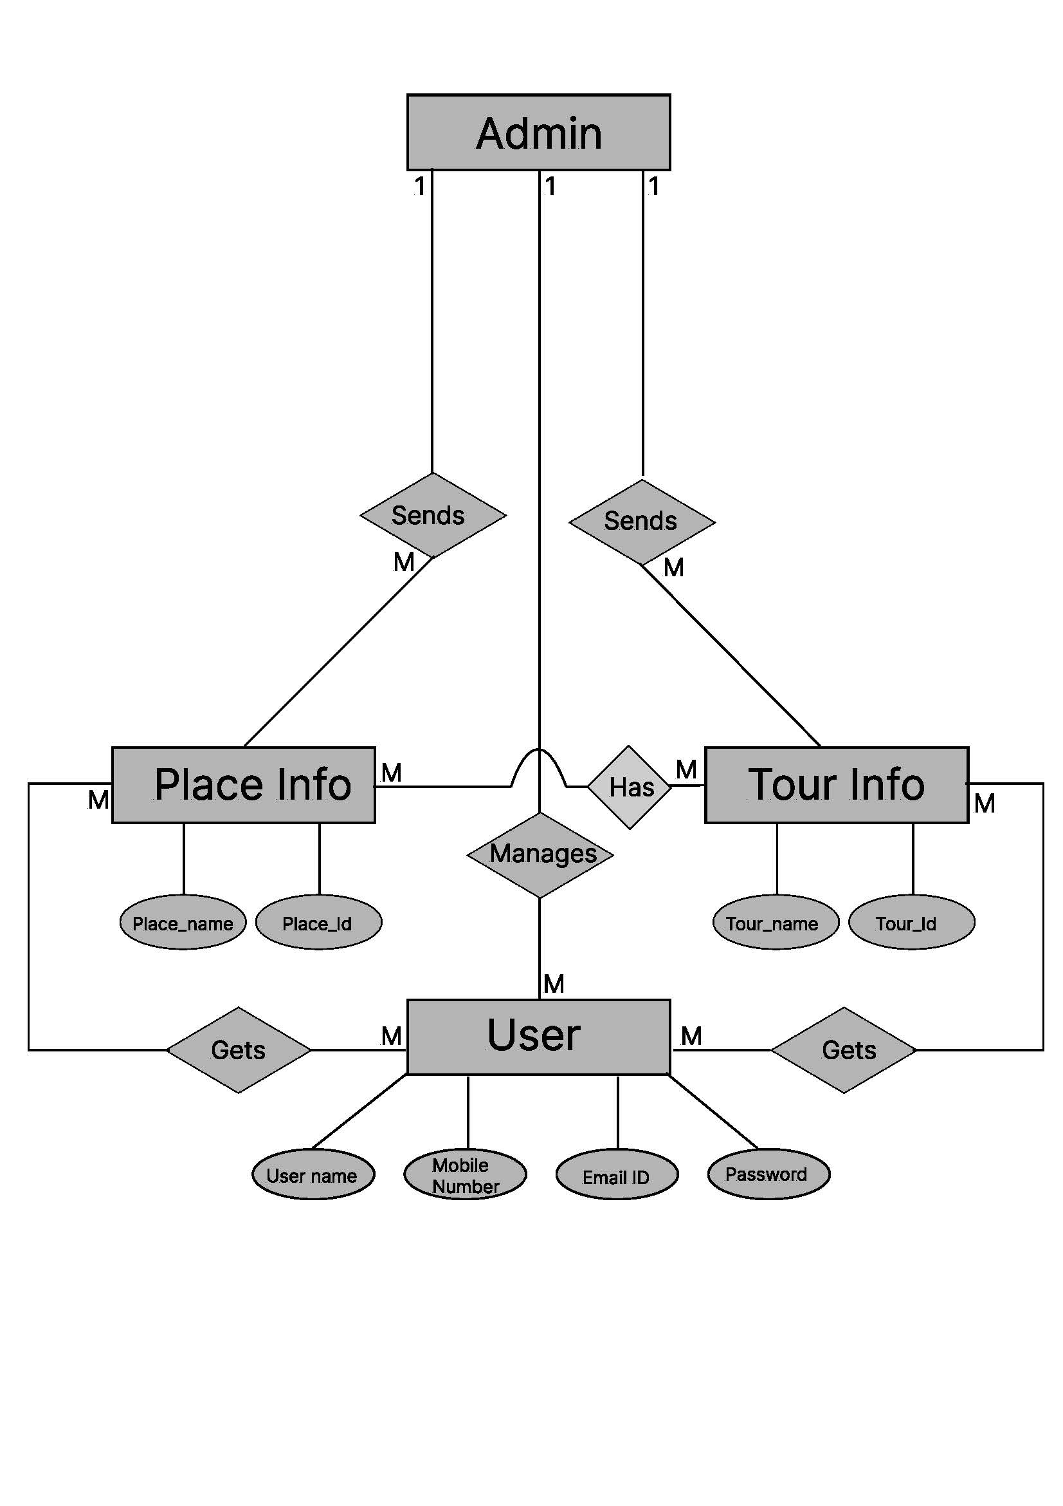

* Data Flow Diagram:-

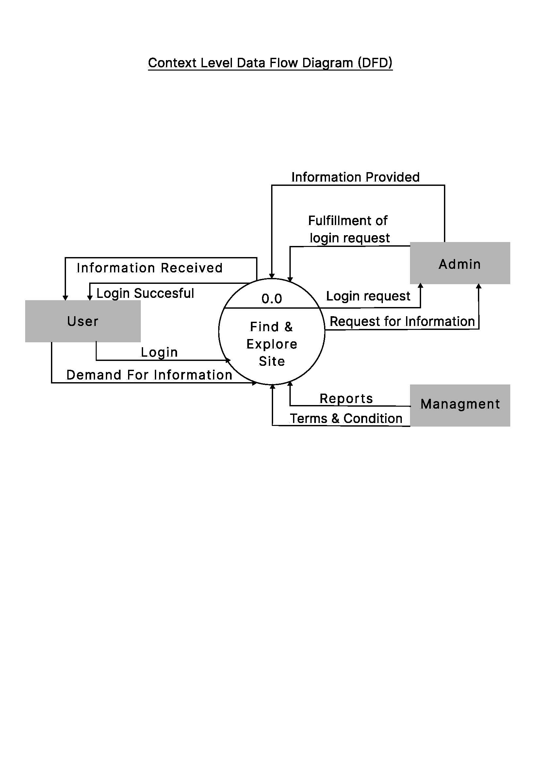

* First Level DFD:-

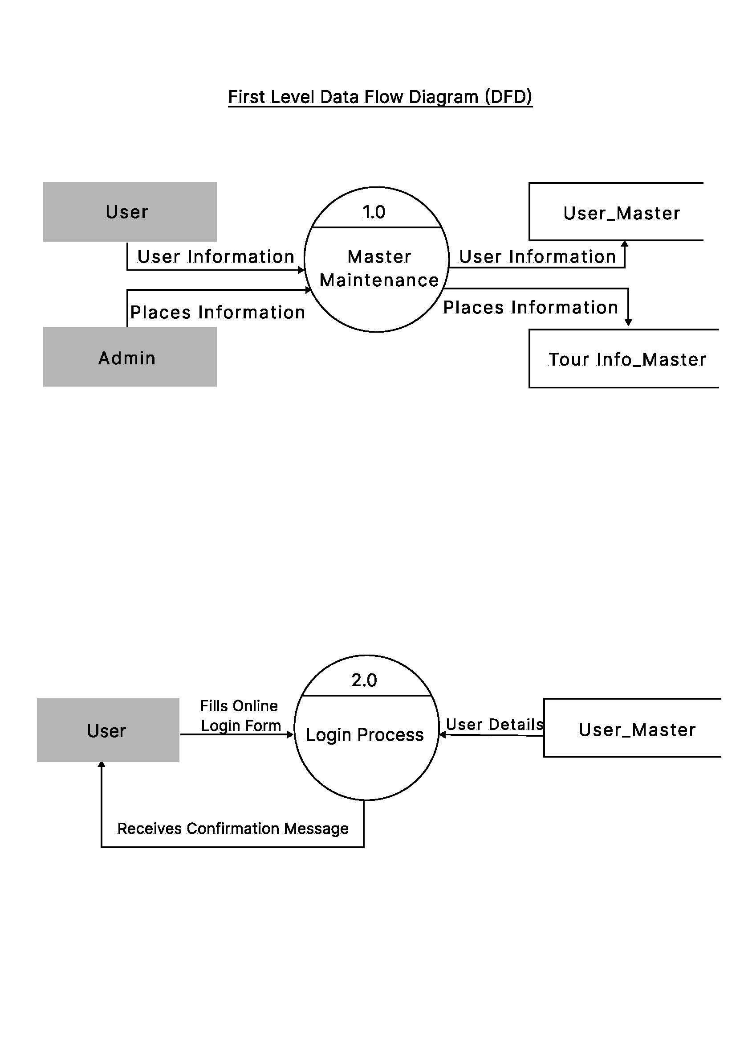

**Form Design-**

* Home Page

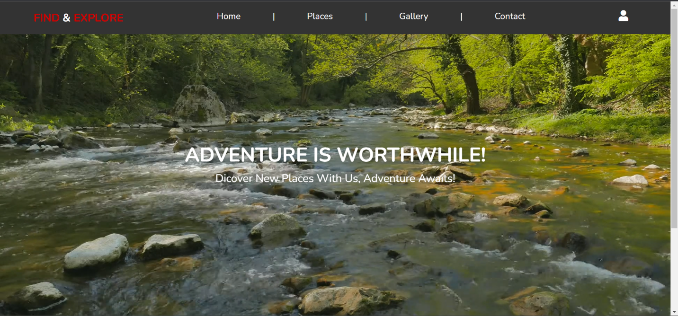

* 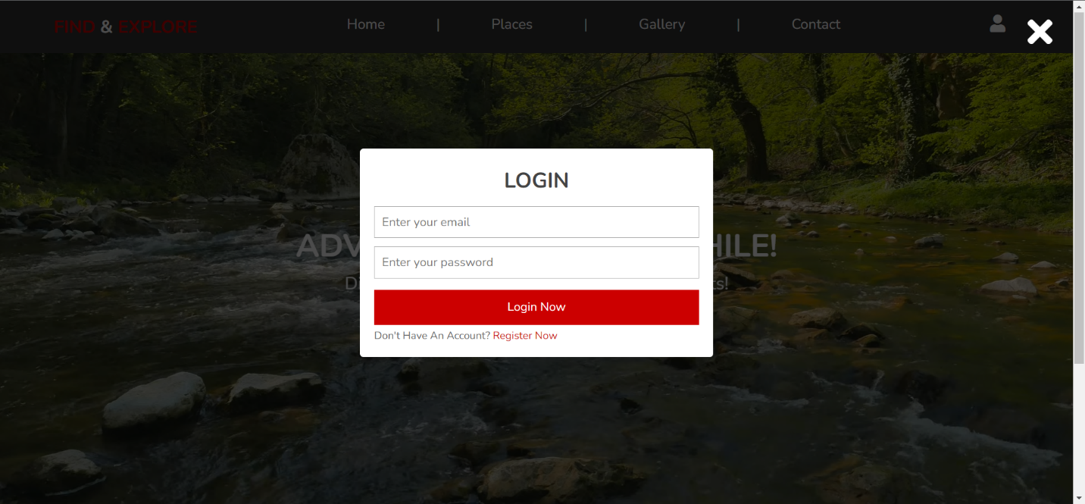Login Page
* 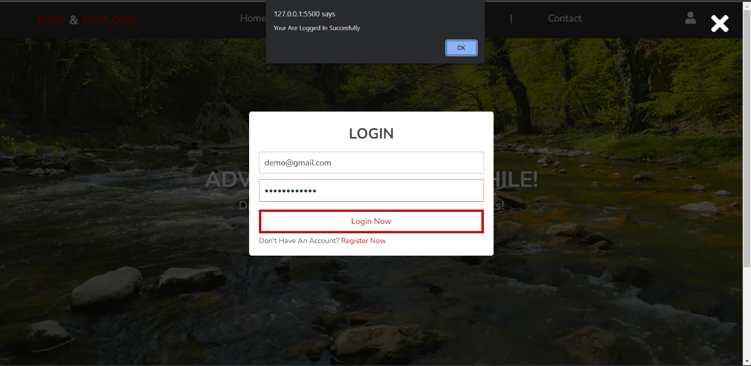Login Successful
* 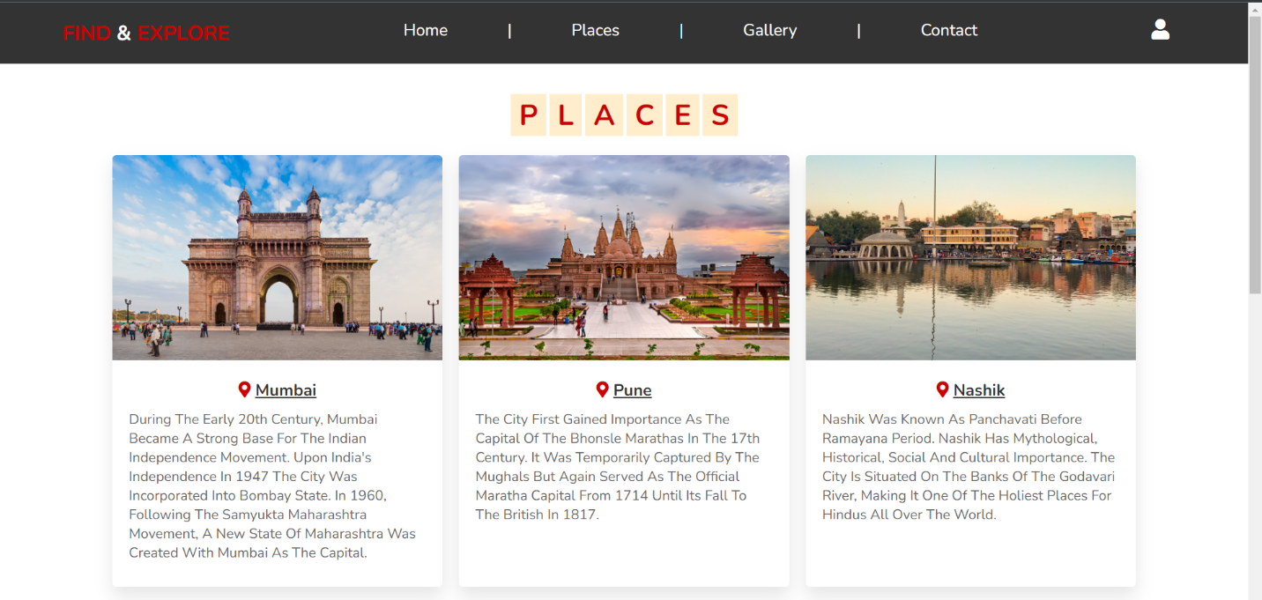Places

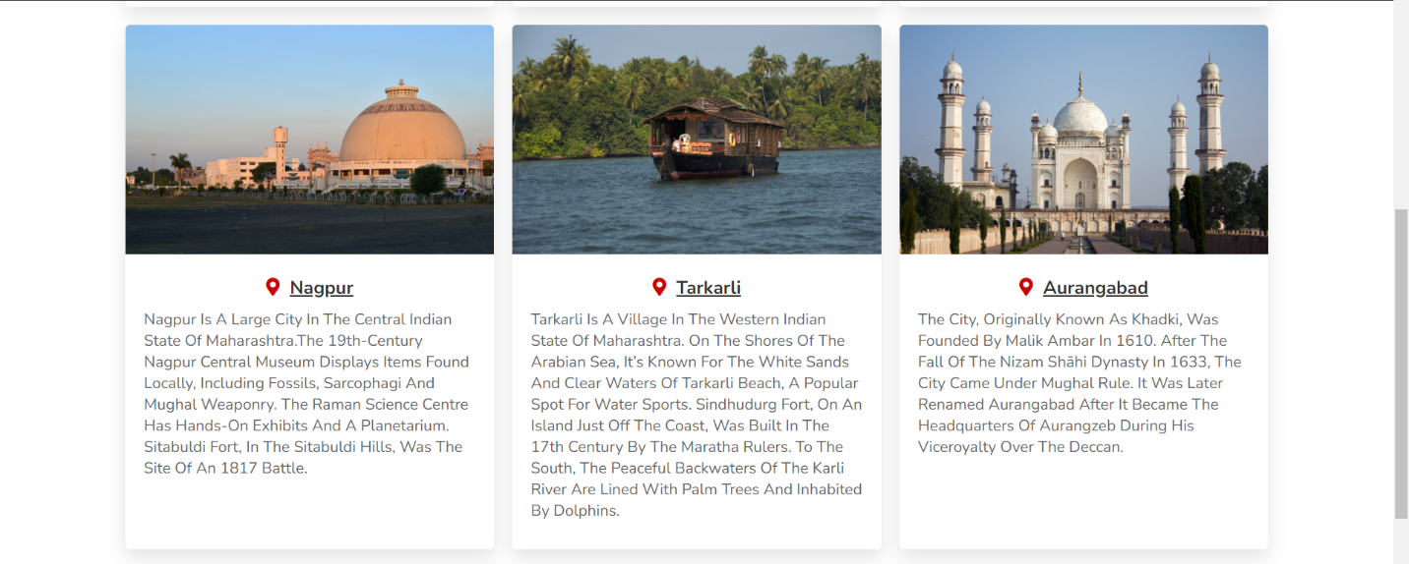

* 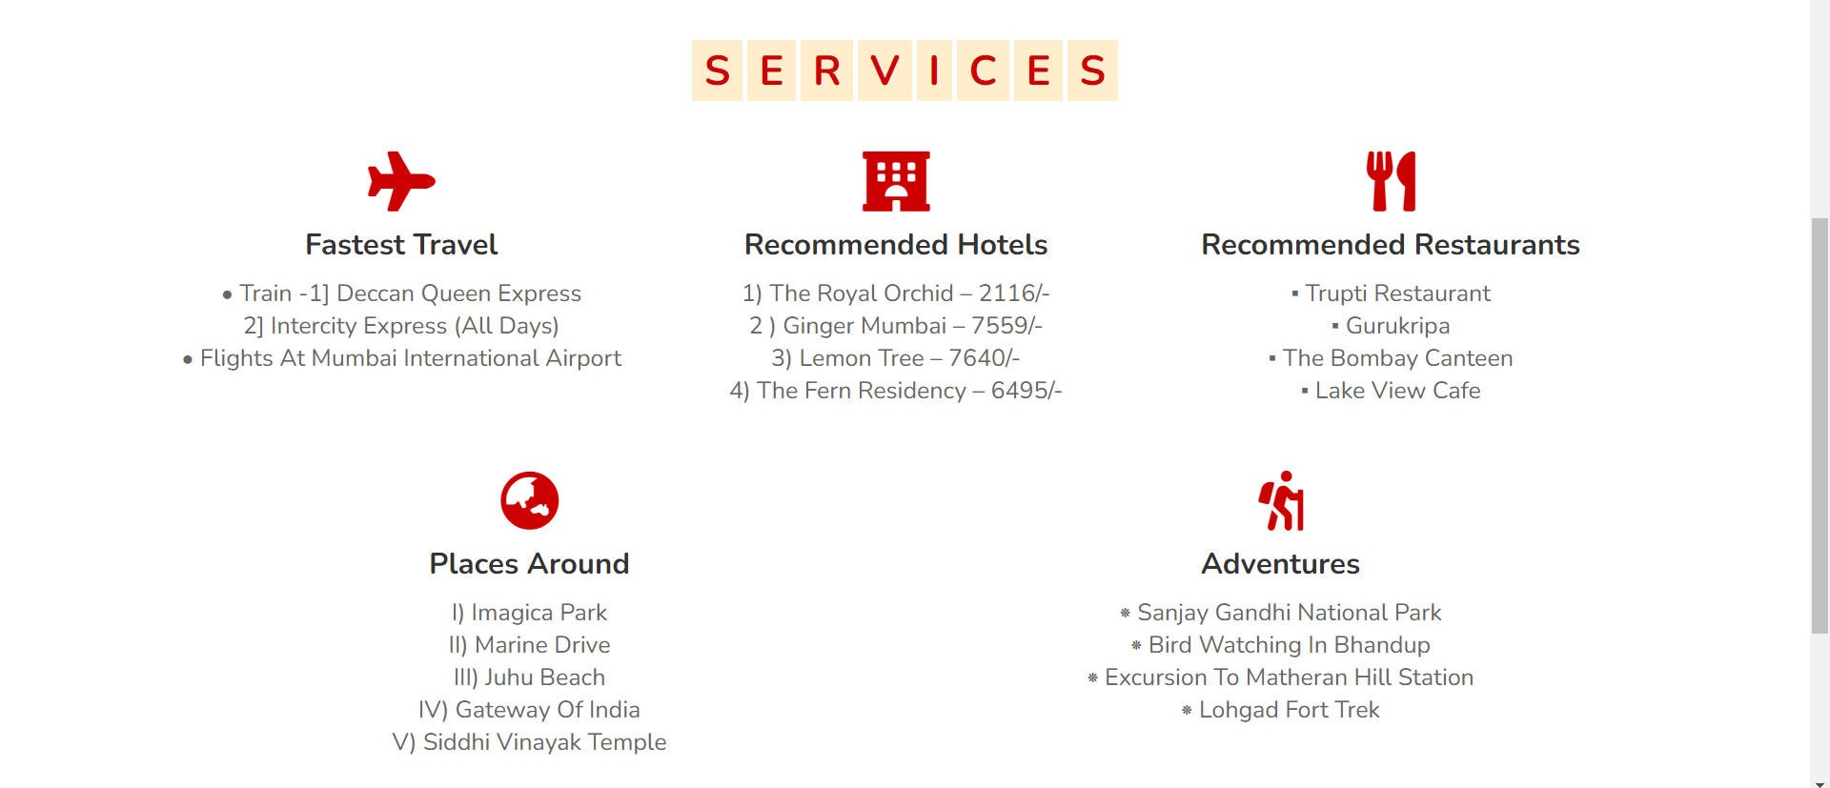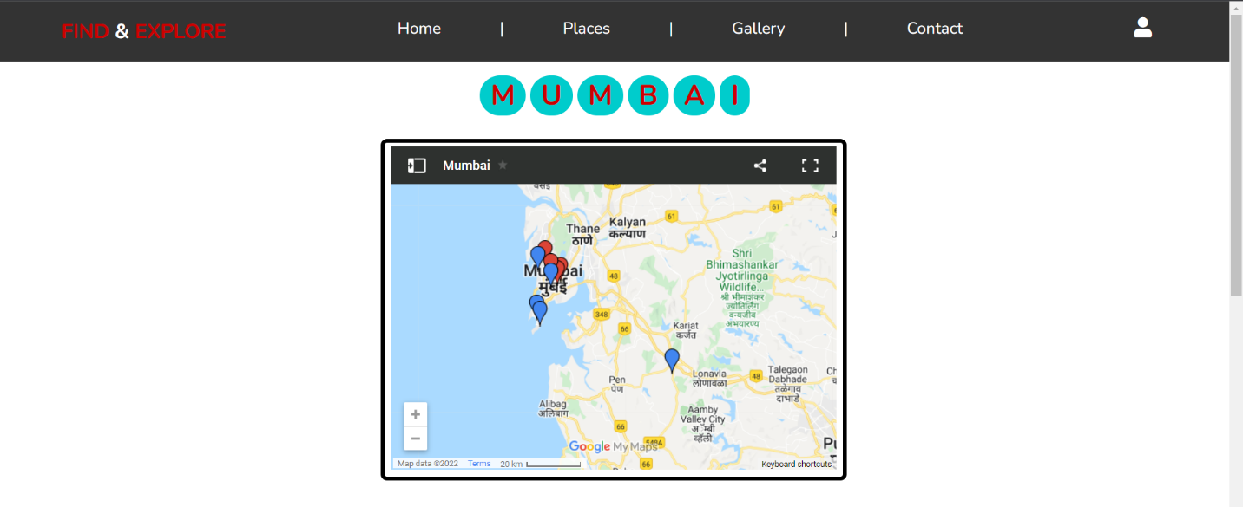Mumbai
* Pune

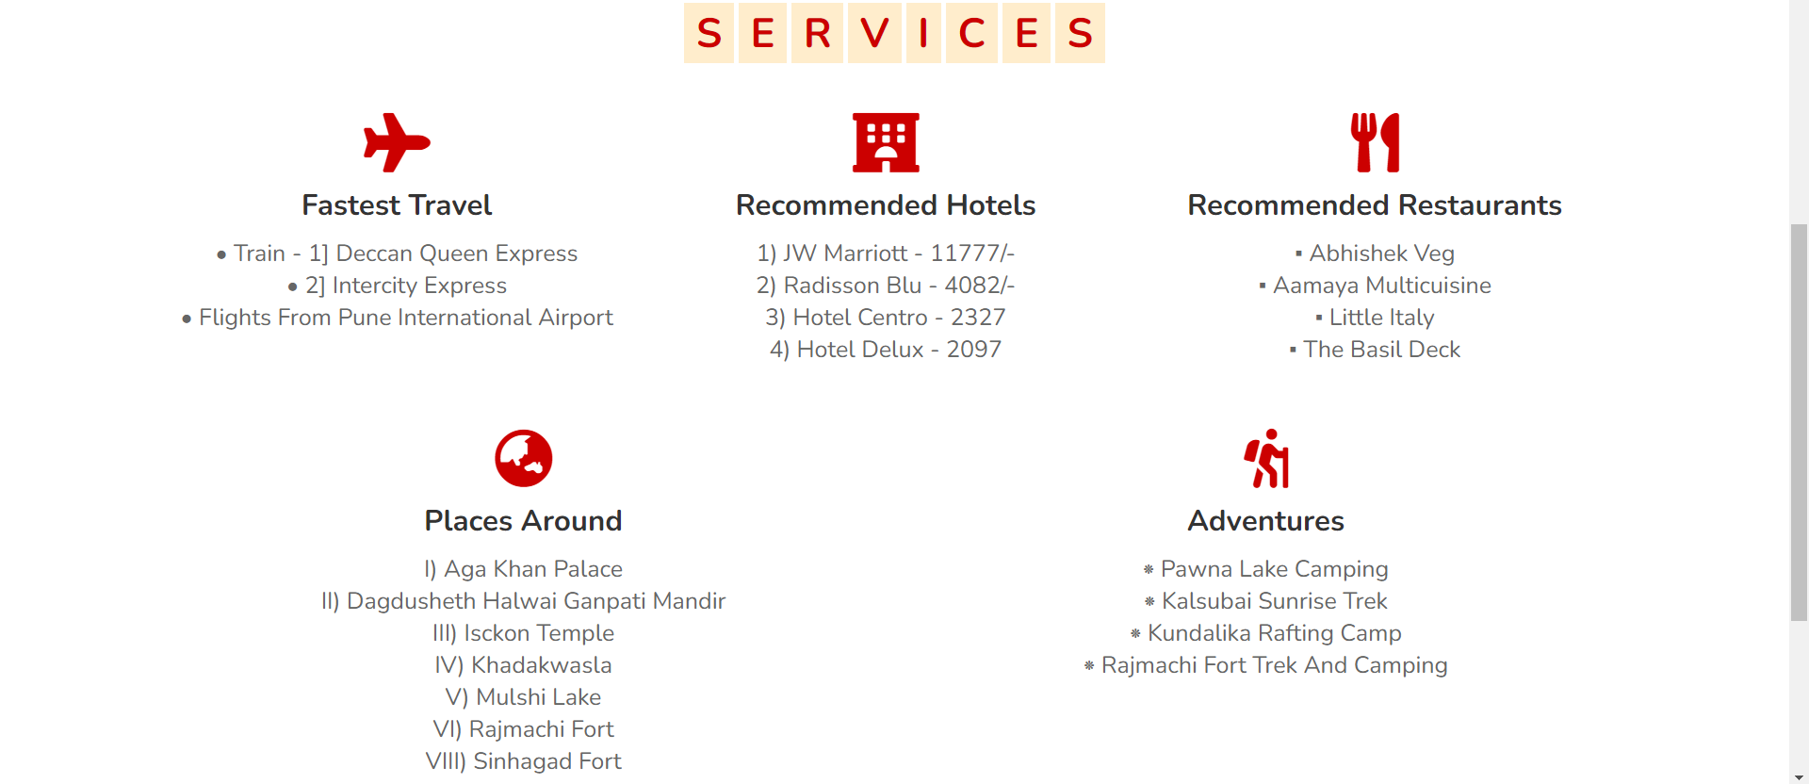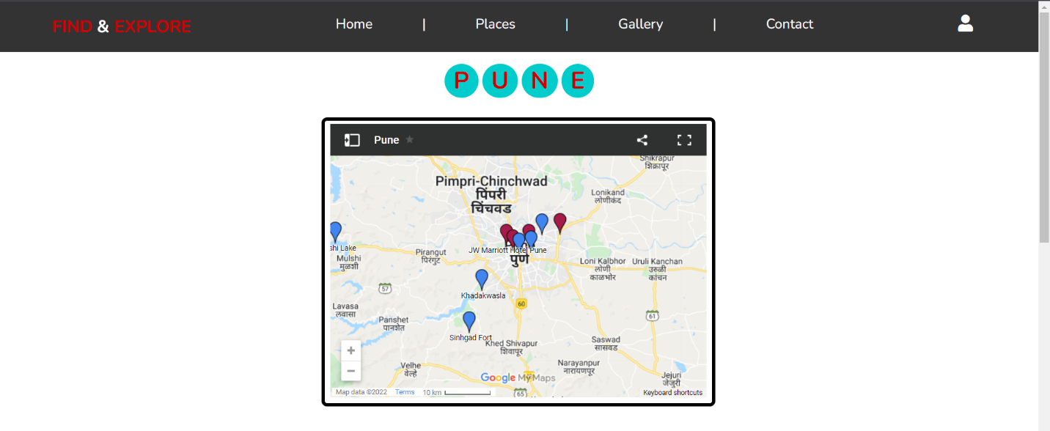

* 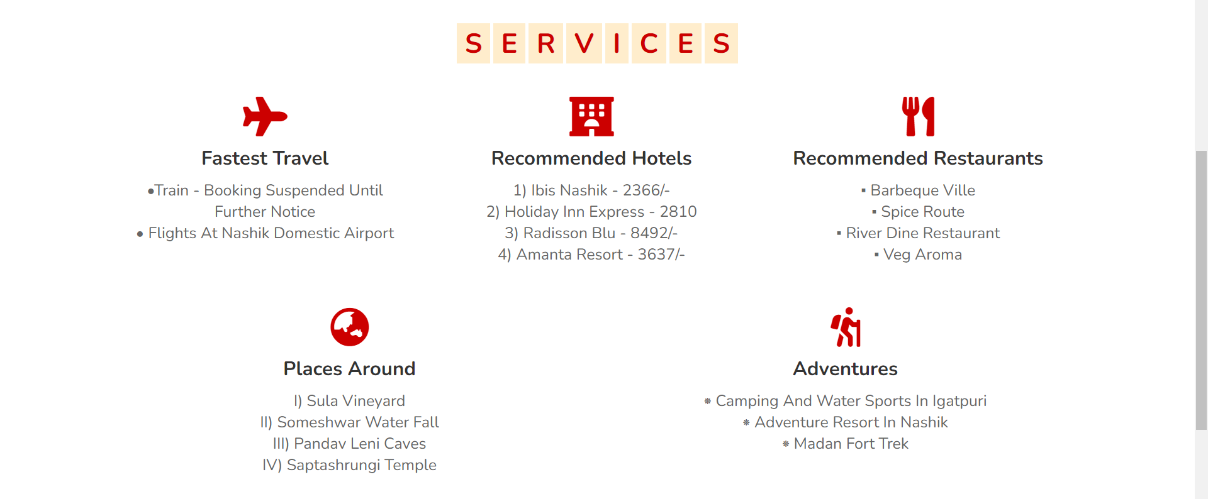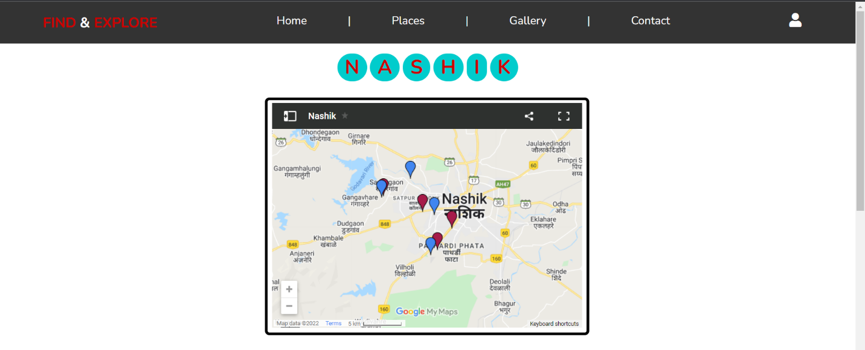Nashik

* Nagpur

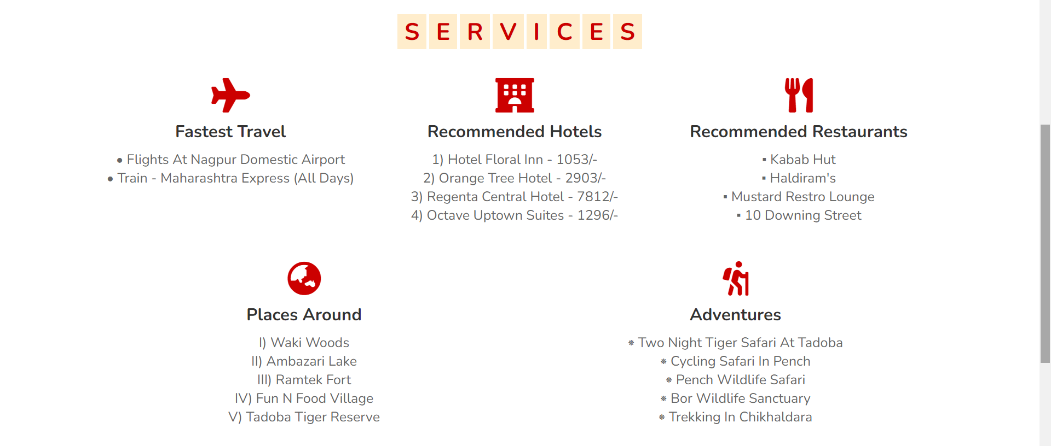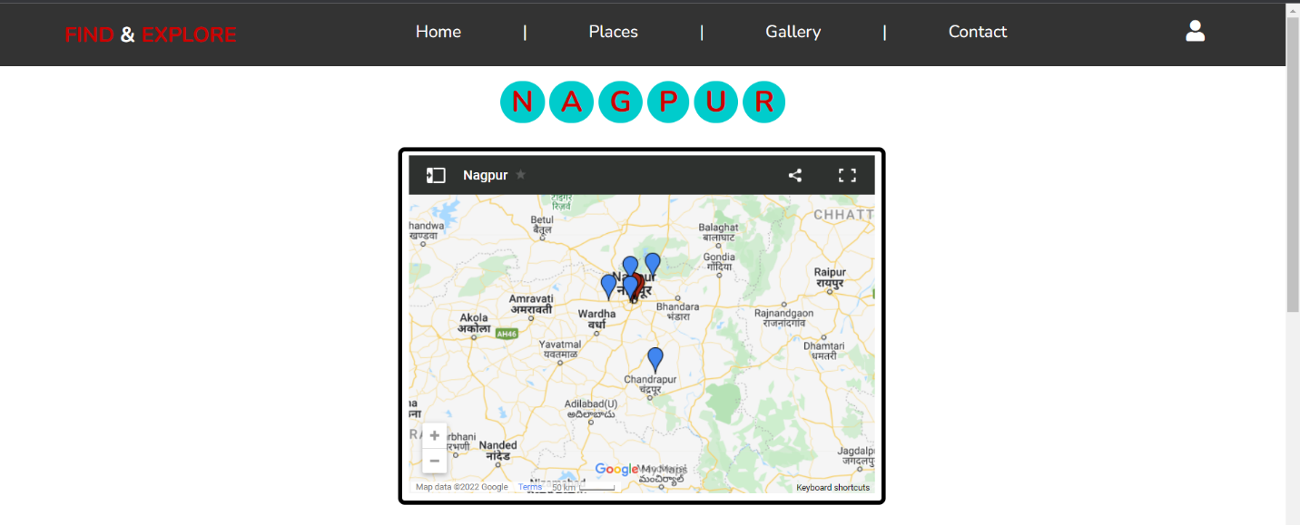

* 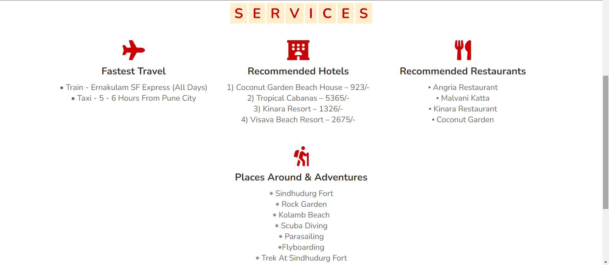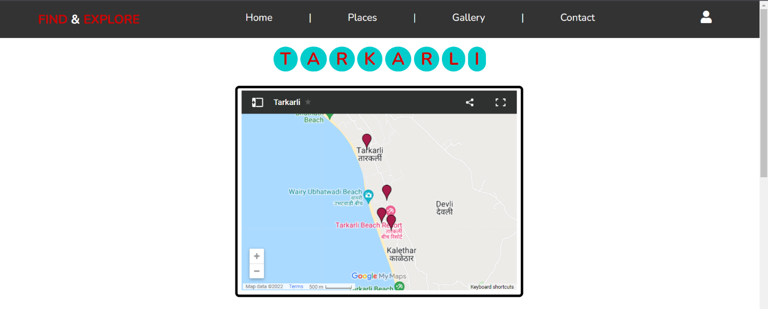Tarkarli
* Aurangabad

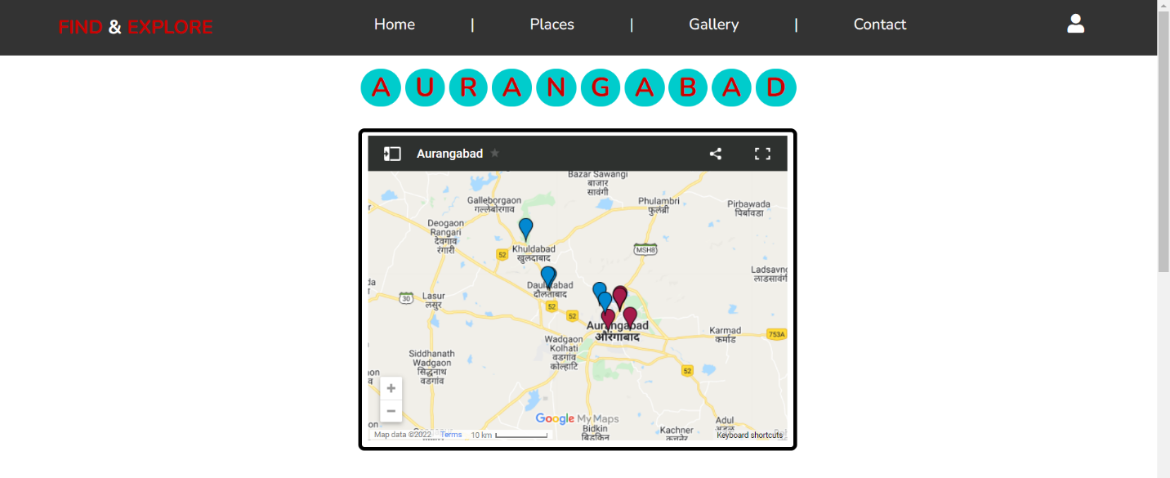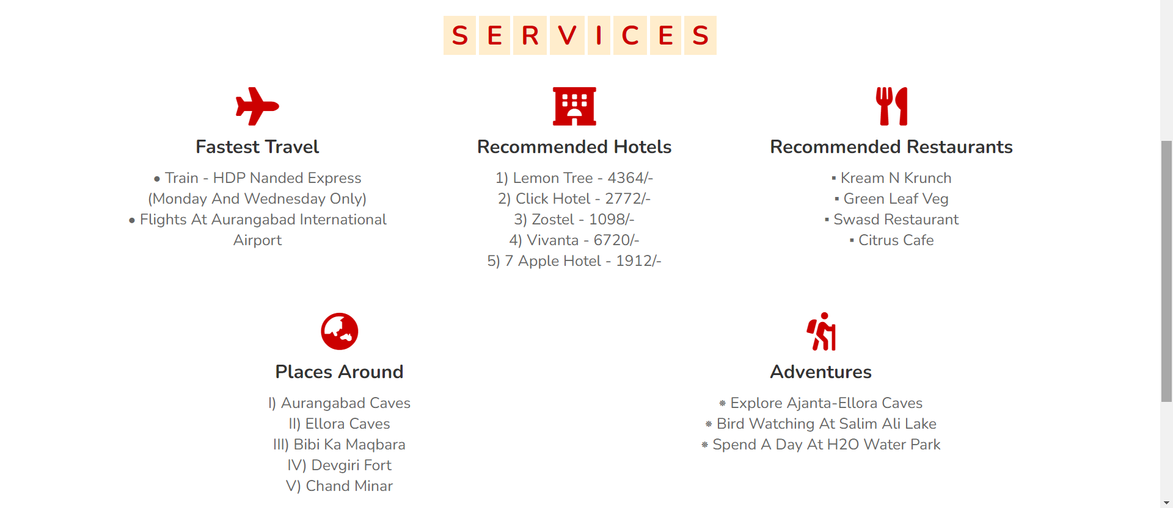

* Gallery

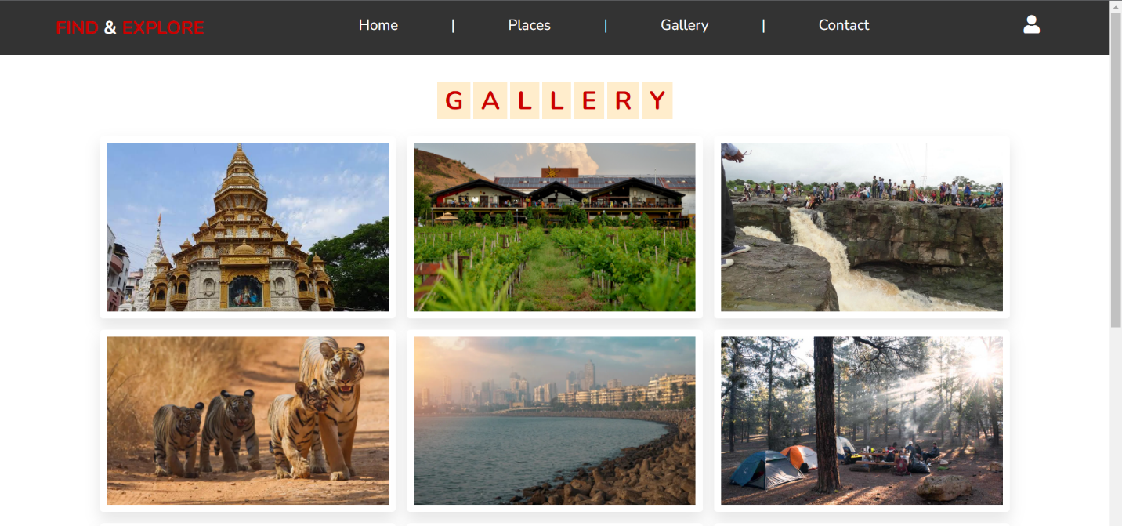

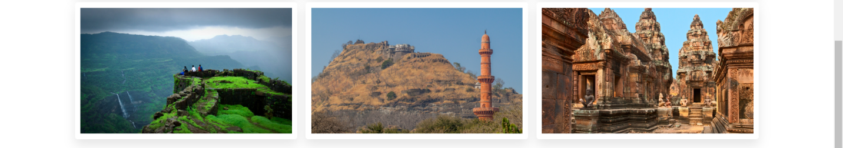

* 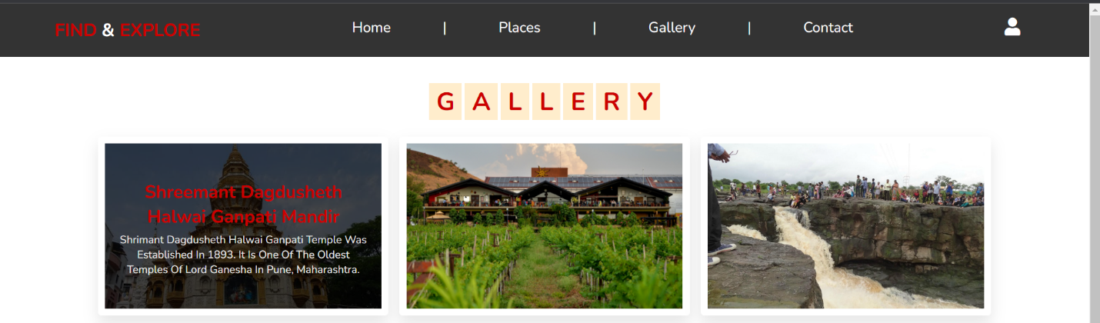Information on Hover
* 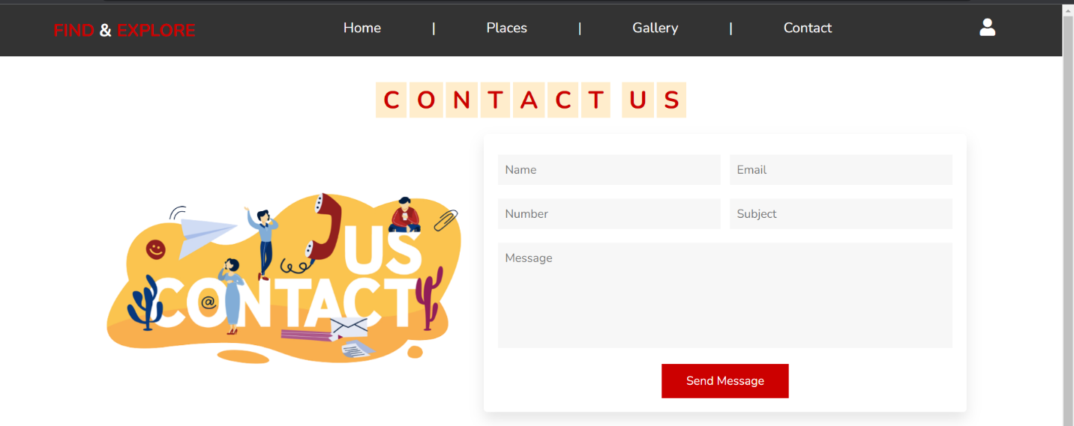Contact Us
* 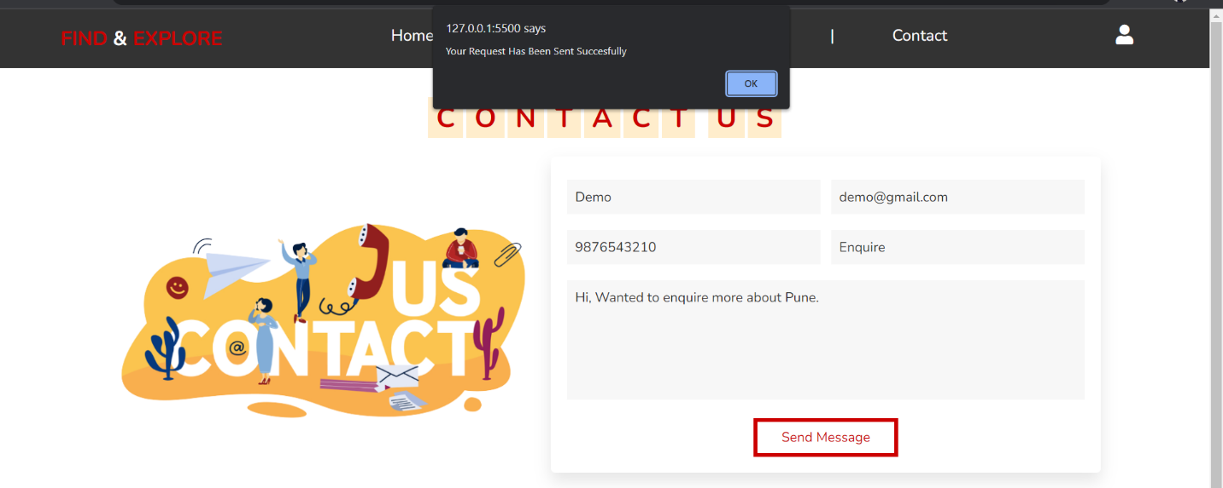Contact Request Submitted
* Footer

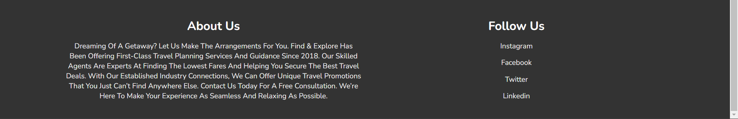

**HARDWARE AND SOFTWARE REQUIREMENT**

Minimum Hardware Requirements: -

1. Processor – Intel Core i3

2. Memory- 4GB RAM

Minimum Software Requirements: -

1. OS- Windows 10

2. Front End-

* Visual Studio Code 1.67.1 or Higher
* Google Chrome 101.0.4951.64 or Higher
* Any other Web Browsing Software
* Requires Stable Internet Connection

**Future Scope:**

* Tourism Information System is a website developed for tourists and tourism destinations that are situated in the State of Maharashtra.
* If this project is brought into use, then it would be much easier for tourists to find relevant information about various travel destinations.
* To provide travel packages at discounted price and accept bookings regarding same.
* To accept feedback from members.
* The capability of this website could be further increased to a larger area if its application is successful.

**Conclusion:**

This website was successfully created to store all the Travel Information like affordable hotels, efficient modes of transport, interesting places to visit and to try local delicacies. After the completion of this website, we conclude that the goal behind the creation of this website was successfully achieved and it is characterized by ease of use in finding the appropriate information. Thus, it was executed perfectly. We look forward to continuing the further development of this project.

**References**

* [**https://angular.io/**](https://angular.io/)
* [**https://stackoverflow.com/**](https://stackoverflow.com/)
* [**https://www.w3schools.com/**](https://www.w3schools.com/)
* [**https://youtube.com/**](https://youtube.com/)
* [**https://www.tripadvisor.in/**](https://www.tripadvisor.in/)
* [**https://www.irctc.co.in/nget/train-search**](https://www.irctc.co.in/nget/train-search)
* [**https://www.shutterstock.com/**](https://www.shutterstock.com/)
* [**https://in.pinterest.com/**](https://in.pinterest.com/)
* [**https://www.makemytrip.com/**](https://www.makemytrip.com/)